Agency Automation Suite - Complete Development Specification
Target: $5M–$50M ARR upper SMB / lower mid-market companies (B2B SaaS, eCommerce, professional services)

Platform Overview
What We're Building: Multi-tenant SaaS replacing 5–10 fragmented martech/fintech tools with outcome-driven AI agents that automate entire roles across revenue operations, finance/ops, and brand marketing.
Core Value:
Manual Process → AI Agent → Measurable Business Outcome
"Send 50 emails" → Account Manager → "$250K pipeline created"
"Create LinkedIn post" → Content Factory → "12 demo bookings"
"Send invoices" → Billing Agent → "DSO reduced 15 days"
Target Metrics: $10K MRR, 40% margins, 20% WoW growth within 6 months

Three Core Suites (12 Agents Total)
1. Revenue & GTM Suite
Solves: Pipeline stagnation, under-serviced accounts, manual SDR work
Agent | What It Does | Inputs | Outputs | Success Metrics
AI Account Manager | Monitors all accounts, finds expansion/churn signals, executes outreach | CRM data, email, product usage, billing status | Personalized emails, meeting bookings, risk alerts to Slack | Pipeline created ($), meetings booked, churn reduction %
Campaign Orchestrator | Plans + runs full-funnel campaigns (email, LinkedIn, ads) | ICP definition, budget, goals | Email sequences, ad campaigns, landing pages, lead routing | MQLs generated, conversion rate, ROI by channel
Lead Qualifier | Scores + qualifies inbound leads 24/7 | Website forms, chat transcripts, social DMs | Sales-ready leads in CRM with scores | Lead velocity, qualification accuracy (>85%), time saved
Demo Booker | Converts conversations → calendar appointments | Lead data, sales playbook, calendar | Confirmed meetings + follow-ups | Meetings booked/week, show rate (>70%), pipeline value
2. Finance & Operations Suite
Solves: Cash flow delays, manual reporting, ops bottlenecks
Agent | What It Does | Inputs | Outputs | Success Metrics
Billing Agent | Manages entire AR lifecycle (invoicing → collections) | Contracts/SOWs, payment terms, invoice history | Invoices sent, payment reminders, cash forecasts, escalations | DSO reduction, cash collected ($), aging bucket improvements
FP&A Copilot | Executive-grade financial analysis + forecasting | Accounting data, CRM pipeline, headcount | Rolling forecasts, scenario models, board decks | Forecast accuracy (>90%), scenario generation speed
Ops Playbook | Executes recurring processes (onboarding, campaigns) | Process templates, connected tools | Tasks executed across apps, human handoffs | Process completion rate (>95%), time saved (hours)
Compliance Monitor | Regulatory/process compliance checks | Transaction logs, policy documents | Audit trails, violation alerts, remediation steps | Compliance score, risk incidents prevented
3. Brand & Social Suite
Solves: Executive content time, vanity metrics, brand inconsistency
Agent | What It Does | Inputs | Outputs | Success Metrics
Persona Builder | Creates/maintains brand + executive voice profiles | Website content, past posts, customer data | Brand guidelines, voice templates | Voice consistency score (>90%)
Content Factory | Generates platform-optimized content at scale | Content calendar, ICP data, performance history | LinkedIn posts, Reels, blogs (10+ formats) | Content velocity (posts/week), engagement rate lift
Social Campaign | Plans/executes brand awareness campaigns | Campaign goals, budget, creative assets | Scheduled content calendar, cross-channel sequences | Pipeline attribution ($), engagement lift
Performance Engine | Measures true ROI, auto-optimizes | All platform data + CRM attribution | Strategy pivots, weekly reports, A/B results | $$ pipeline from content, cost/lead

Technical Architecture
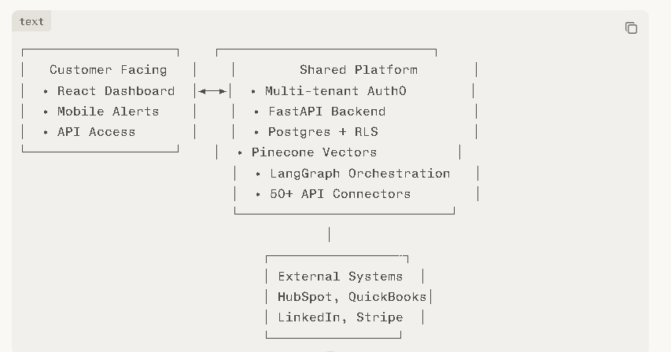

Data Ingestion (Priority #1)
70% APIs + Webhooks, 20% Forms, 10% Custom
Method | Tools | Task
APIs | HubSpot, QuickBooks, LinkedIn, Gmail | Build OAuth2 connectors using Apideck SDK
Webhooks | Real-time events (new deal, payment) | /webhook/{tenant_id} endpoint
Forms | Onboarding wizard, CSV upload | React forms → LLM parsing → structured data
Fallback | Google Sheets sync | Scheduled Airtable/Sheets connector
MVP Connectors (Build These First):
1. HubSpot (CRM) 6. Gmail
2. QuickBooks 7. LinkedIn API
3. Stripe 8. Slack
4. Pipedrive 9. Google Analytics
5. Intercom 10. Xero

Development Roadmap (12 Weeks)
Phase 1 : Core Platform + Revenue MVP
Multi-tenant auth, 5 core connectors
AI Account Manager + Lead Qualifier
React dashboard + onboarding flow
Phase 2 : Brand Suite + Analytics
Persona Builder + Content Factory
Performance dashboard + attribution
Social connectors (LinkedIn, Instagram)
Phase 3 : Finance + Polish
Billing Agent + FP&A Copilot
All Teams: Testing, docs, demo videos

